Requirements for a Restaurant Application

# Customers-

-Register /Login

-Search Restaurant

-Search Food

-View Menu

-Place Order

-Make Payment

-Track Order

-Give Ratings/Reviews

-Cancel Order

# Restaurant Partner-

-Register/Login

-Manage Menu

-Accept Orders

-Reject Orders

-View Earnings

-Update Order Status

# Delivery Partner-

* Register/Login
* View Earnings
* View Assigned Orders
* Accept Delivery

-Reject Delivery

# Admin-

Manage Users Manage Restaurants Handle Complaints Monitor Transactions Generate reports

# UML DIGRAM

Requirements for a food Application:

# Customers-

-Register /Login

-Search Restaurant

-Search Food

-View Menu

-Place Order

-Make Payment

-Track Order

-Give Ratings/Reviews

-Cancel Order

# Restaurant Partner-

-Register/Login

-Manage Menu

-Accept Orders

-Reject Orders

-View Earnings

-Update Order Status

# Delivery Partner-

* Register/Login
* View Earnings
* View Assigned Orders
* Accept Delivery

-Reject Delivery

Admin-

Manage Users Manage Restaurants Handle Complaints Monitor Transactions Generate reports

USE for restaurant application Diagram

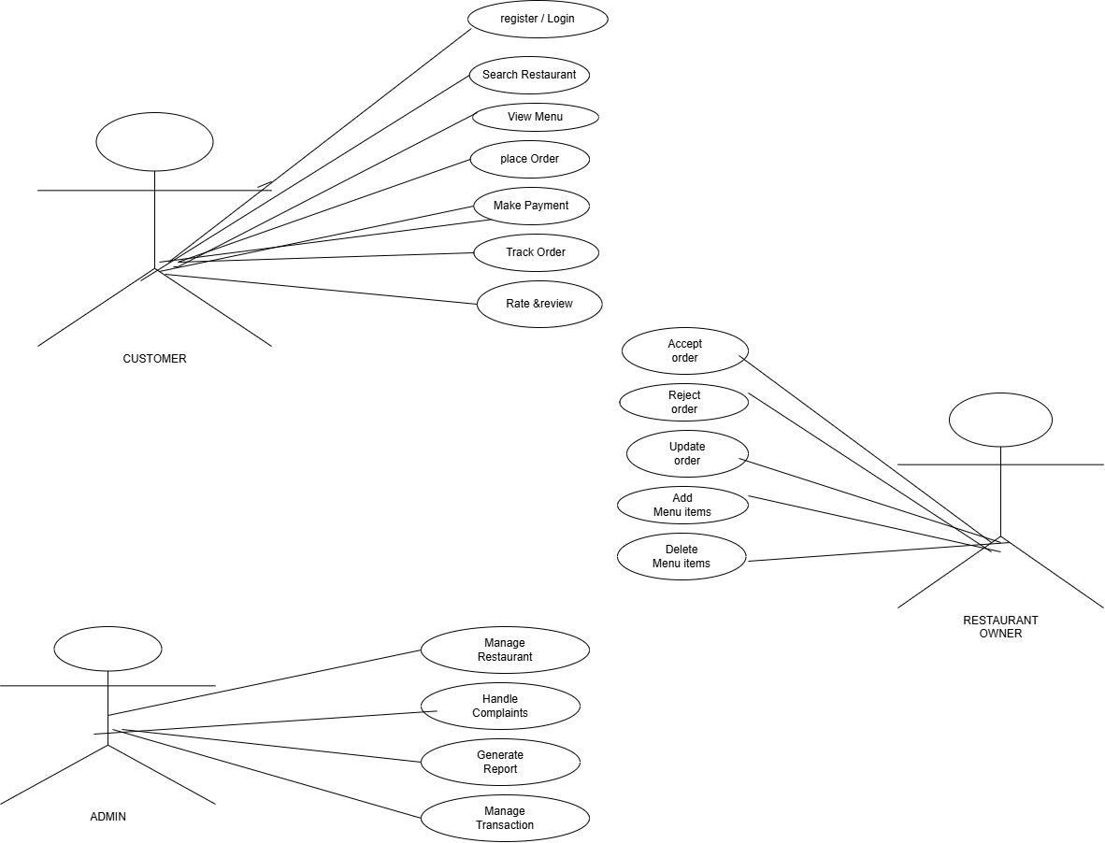

Class diagram for Restaurant Application:

